December 2022
Dear IPNFA® Members,

I hope this message finds you all healthy and safe with your families and friends.
This year of 2022 we have a lot to celebrate!! After two years without our real AGM, we finally could be together again in Frankfurt. Unfortunately, with all the effort of our Japanese instructor Shozo, the AGM was not possible in Okinawa, due to the pandemic restrictions in Japan. We must strongly thank Kitty and Marianne for making our meeting possible in Frankfurt, in such a short time. Even though we didn´t have the Education Day, at least we could have Instructor and Business Days, where we had the opportunity to discuss many important topics for our association.
For the first time we have tried to have a hybrid event, as we have voted on in 2021. It was not exactly as we planned and wished, because the internet was not strong enough for what was necessary for this type of transmission. We apologize for that and we are making sure that next year, in Bulgaria, we will have the appropriate internet for that.
Our Online Congress had it’s 3rd edition in September, again with a great success. We must thank the speakers of this year, Carsten, Benedikt, Marcel, Ulla, Frits and the Vallejo Team for all the hard and great work done!! We really hope that our great instructors feel motivated to participate in the next ones.
The repercussion of our online lectures, during the Online Congress and even more after the congress, from leaving most of the lectures on our Youtube channel, has been unbelievable!! The number of views still increasing day by day. The subtitles, this year in Portuguese, Japanese and Spanish had also helped a lot to make possible for those ones who cannot understand English.
For next year we are planning to upgrade the platform we are using, in order to increase the quality of our Online Congress. You will receive an email with the results of our 2022 Online Congress and with the details for this platform upgrading.
We are really looking forward for our next AGM in Sofia – Bulgaria next year! By now, we are working on the schedule of the Instructor, Business and Education Days, and also setting the lectures for our 4th Online Congress.
I hope to see you all in Bulgaria in October!!!

May this Christmas season bring you closer to all those that you treasure in your heart. Merry Christmas and a Happy New Year!!!!

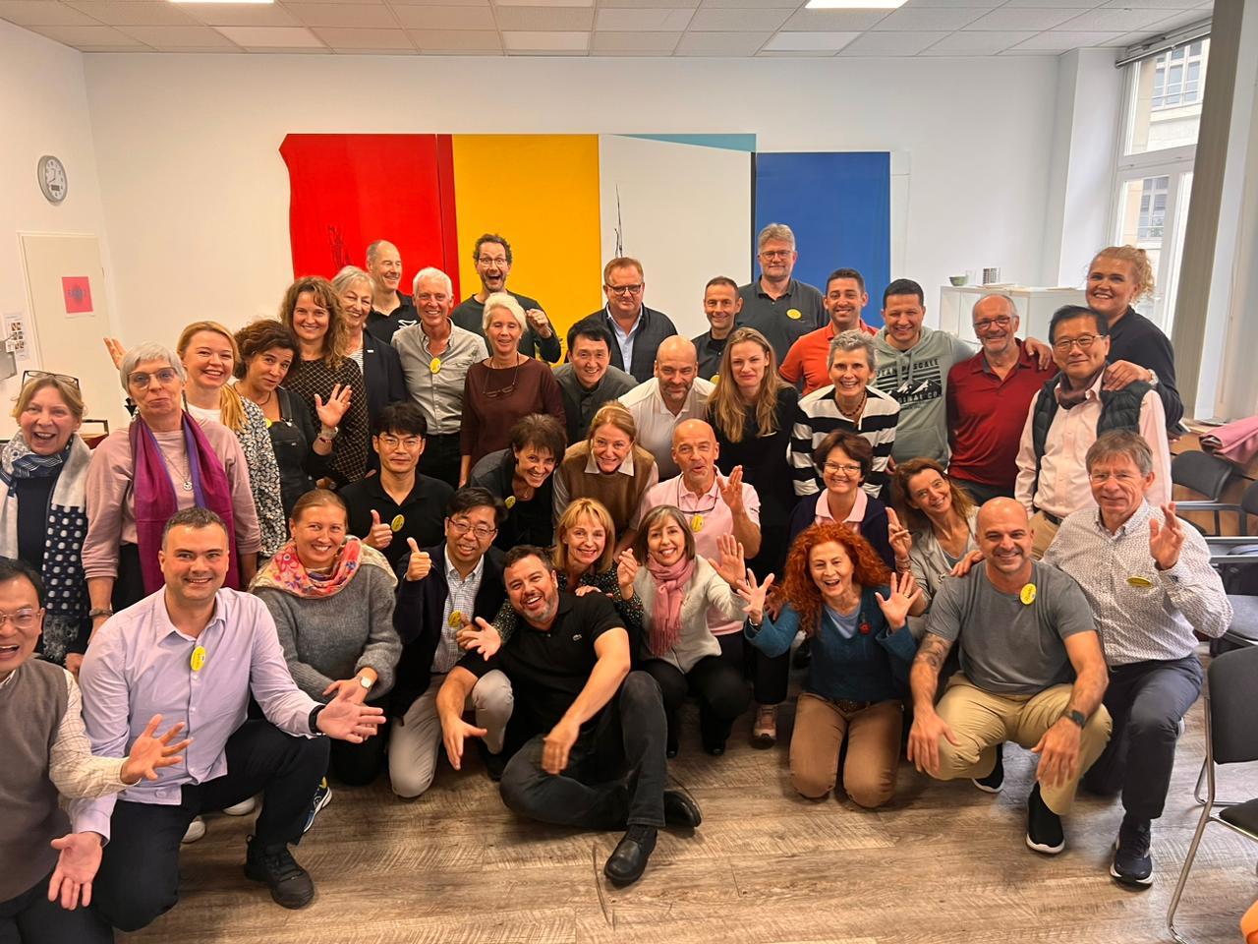
“So happy to be together again!!!”

Mônica Cilento
IPNFA® President

