_______________________________________

Motor Control
_______________________________________

1. Definition and Contributions of Motor Control
2. Postural control
3. Activities

1. Definitions and Contributions
  - Definition of Motor Control

“Motor control is defined as the ability to regulate or direct the mechanisms essential to movement.”
(Shumway-Cook & Woollacott 2011, p.4; Horak et al 1997)
Relevant questions are:
- “How does the central nervous system (CNS) organize the many individual muscles and joints into coordinated functional movements? (Bernstein 1967; Shumway-Cook & Woollacott 2011; Magill 2003; Schmidt & Lee 2011)
- How is sensory information from the environment and the body used to select and control movement?
- What is the best way to study movement, and how can movement problems be quantified in patients with motor control problems?” (Shumway-Cook & Woollacott 2011, p.4)

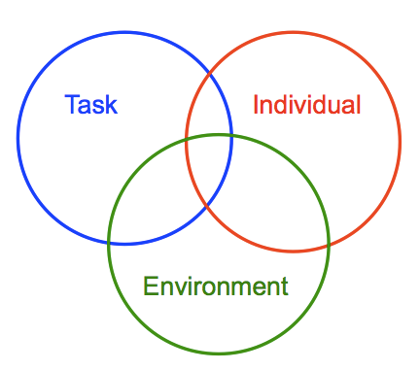

“Movement emerges from interactions
between the individual, the task and the
environment.”
(Shumway-Cook & Woollacott 2011, p.5)

figure 1: adapted from Shumway-Cook (Shumway-Cook & Woollacott 2011)

  - Theories of Motor Control
    - Reflex Theory e.g. Sir. Ch. Sherrington (Sherrington 1947)
    - Hierarchical Theory e.g. Rudolf Magnus, Arnold Gesell
    - Motor Programming Theory e.g. Karl Lashley (Fitch & Martins 2014)
Nicolai Bernstein … as a base for the Systems Theory (Bernstein 1967)
    - Systems Theory / Dynamic Action Theory / Dynamic Pattern Theory -
self organizing systems e.g. J.A. Scott Kelso, Viktor Jirsa (Jirsa & Kelso 2004)
    - Ecological Theory e.g. James Gibson (Gibson 1983)

  - Sensory Contributions to Motor Control

For the closed-loop control system, sensory (or afferent) information is necessary to regulate our movements (Adams 1971; Schmidt & Lee 2011).

    - Vision
    - Audition
    - Cutaneous Receptors
    - Proprioception
    - Muscle Receptors
      - Muscle Spindels
      - Golgi Tendon Organs
    - Joint Receptors
    - Vestibular System
(Shumway-Cook & Woollacott 2011; Schmidt & Lee 2011; Horst 2005; Adler u. a. 2013)

  - Central Contributions to Motor Control

In the open-loop control system the instructions for a movement are structured in advance. While executing the movement possible effects on the environment can´t be taken in account for correction. (Schmidt 1975; Schmidt & Lee 2011)

    - Central Pattern Generators
    - Reflex involvement in Locomotion
    - Agonist-Antagonist Patterning
    - Reciprocal Inhibition
    - Generalized Motor Programs (in order to reduce the storage problem)
    - Timing of Events
(Schmidt & Lee 2011; Shumway-Cook & Woollacott 2011)

2. Postural Control
  - Postural control involves controlling the body's position in space for the dual purposes of stability and orientation. ... Postural control requirements vary with the task and environment (Shumway-Cook & Woollacott 2011).

  - “Postural stability (balance), is the ability to control the centre of mass in relationship to the base of support. Stability limits are considered the boundaries within which the body can maintain stability without changing the base of support.” (Shumway-Cook & Woollacott 2011, p.160)

  - Anticipatory postural control (by brain stem nuclei, supplementary and premotor areas etc. …) means to ready the involved systems for the upcoming action (Shumway-Cook & Woollacott 2011; Kandel u. a. 2012).

  - “Postural orientation is defined as the ability to maintain an appropriate relationship between the body segments (alignment), and between the body and the environment for a task.” (Shumway-Cook & Woollacott 2011, p.158; Horak & Macpherson 2010).

    - Variables which influence the amount of the challenge of a motor task (e.g. postural control)
      - amount of base of support (B.o.S.)
      - height of centre of mass (C.o.M.)
      - location of centre of gravity (C.o.G.) in relation to border of B.o.S.
      - degrees of freedom
      - body mass
      - necessity for eccentric, concentric or static contractions
      - stable or instable environment
      - open or closed muscle chain by position
      - open or closed motor task
      - velocity, acceleration, momentum, effective torque
      - external weight or resistance
      - external perturbation
      - …
(Gentile in Carr & Shepherd 2000; Schmidt & Lee 2011; Shumway-Cook & Woollacott 2011; Horst 2005; Lord u. a. 2007)

    - Postural control emerges from the interaction of the following systems
      - musculoskeletal systems
      - neuromuscular synergies
      - sensory strategies
      - anticipatory mechanisms
      - adaptive mechanisms
      - internal representations
      - individual sensory systems
(adapted from Shumway-Cook & Woollacott 2011)

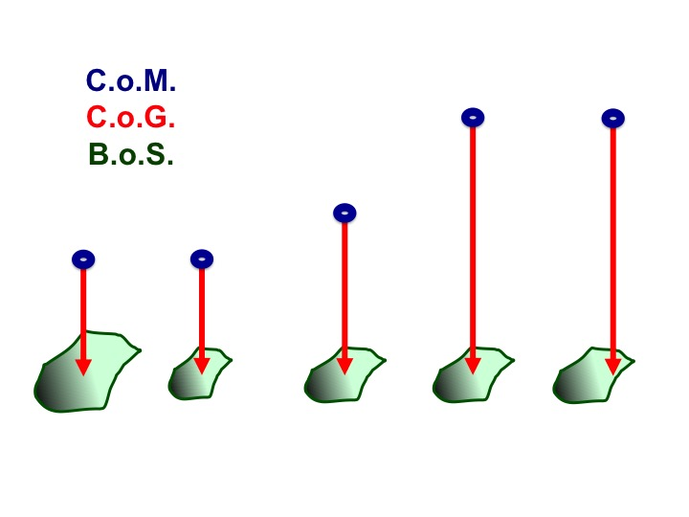

figure 2:
Example - increasing challenge of the postural control from position 1 to 5

(Schaefer, 2013)

3. Activities

  - Maintaining a position and Transfer
The ability to change positions, wether moving from sitting to standing, rolling, rising from a bed, getting up from the floor and of course walking, is a key feature of our independence as human beings. PNF-Therapists therefore must be able to define the relevant requirements:
- The essential characteristics of the action (biomechanics, kind of muscle work against gravity etc.)
- The sensory motor strategies that normal individuals typically use to accomplish the task (movement patterns and timing)
- Adaptations required for changing environmental characteristics (Shumway-Cook and Woolacott, 2011) or motor impairment (e.g.: “Trick-Movements” in spinal cord injuries)

figure 3: „Stages of motor Control Model“ for analysis and grading of motor control problems for defined activities (Stockmeyer 1967; Minor u. a. 1982)
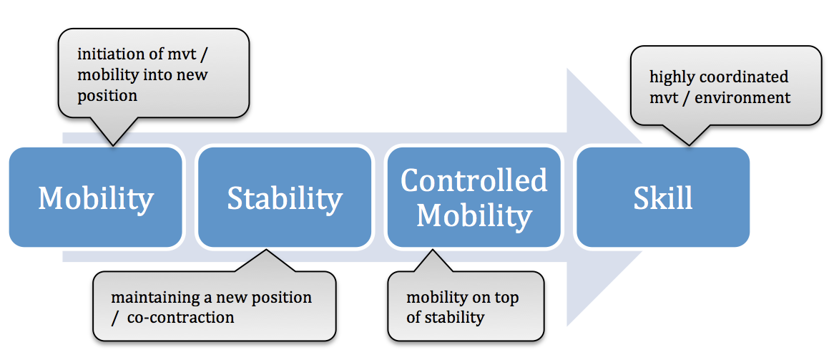

adapted from Stockmeyer 1967, and Minor 1982

Example: Transfer - Sit to stand (STS)

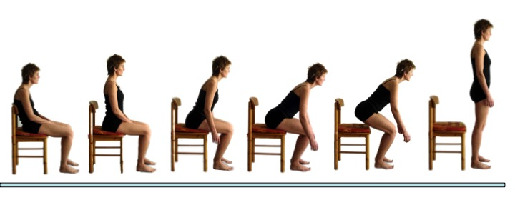
    - Essential characteristics: STS can be devided into a pre-extension and an extension phase (Carr & Gentile 1994, Shepherd & Gentile 1994) In the pre-extension phase the (stable) upper body leans forward by flexion at the hips and dorsiflexion at the ankles. In the extension phase, extensor muscles crossing the hip, knees and ankles accelerate the body mass vertically.
figure 4: (Schaefer, 2008)

    - Sensory-Motor Strategies: Since the thighs and feet are supported, ground reaction forces play an important part of muscle power and enable the propulsion of the body mass in the desired direction. Muscle-activity found by electromyography (EMG): rectus abdominis, lumbar paraspinals and trapezius (to stabilize the trunk), gluteaus medius, quadriceps, hamstrings, tibialis anterior, gastrocnemius and soleus (Muntan et al. 1984, Richards 1985, Arborelius et al. 1992, Khemlani et al. 1998)

    - Adaptations: The extent of angular displacement at the hips varies depending on the height and type of seat, presence or not of chair arms, starting position and wether the arms are free to move or used for support and balance.

Defining Prerequisites for STS by using the “Stages of motor control”:

    - Mobility: Critical points may be enough ROM in dorsiflexion of ankles (around 15°, Shepherd and Koh, 1996), ROM of knees and hips and elasticity of hipextensor- and posterior tibial muscles.
    - Stability: To start the movement, the trunk should be stable in an upright, symmetrical position, feet and legs stable in alignment.
    - Controlled mobility: While trunk and axis of legs must be kept stable, hips, knees and ankles must be extended in a smooth, controlled way (pre-extension phase: eccentric muscle-work – quick enough to cause momentum, extension-Phase: concentric muscle-work)
    - Skill: STS in an unpredictable environment (ex: inside a running bus, getting up from a moving rocking-chair or a swing) or in a multitasking situation.

Defining and grading difficulties, the patient might have with an activity by using “the stages of motor control - taxonomy” enables the PNF-therapist to create optimal tasks and pick out the most appropriate PNF-technique for facilitation.

  - Reaching, Grasping: requirements and features

    - Eye-hand coordination
      - Reaching a body part
      - Reaching an external target

    - eye-head-hand coordination (incl. timing of movements)
In order to reach and grasp, the motor control system needs to build a functional unit of hand arm and shoulder girdle. Functional stabilization of the scapula on the rip cage is as important as the timing of the single movements of eyes, head, trunk, arm and fingers.

    - force adaptation and postural adjustment (or irradiation)
Reaching, pulling and pushing something provoke strategies of trunk-stabilization in order to keep a stable position, the body alignment and orientation.

(Shumway-Cook & Woollacott 2011; Magill 2003; Wulf 2009; Kandel u. a. 1995)

Example: Reaching for and grasping a glass in sitting

    - Essential characteristics: Reaching for and grasping an object is considered to be controlled by different areas of the brain. A) fast reach component to get the arm close to the object B) slower grasp component to adjust the grip.
The muscles between scapula and trunk/ribcage need to create a stable origin for the arm muscles (anticipatory and during the arm movement). Arm muscles rather have to work concentrically (against gravity), whereas trunk muscles keep the alignment by rather static working muscles. After initiating the leaning forward movement of the trunk, this trunk torque (into flexion) has to be controlled eccentrically mainly by the hip-extensors.

    - Sensory-Motor Strategies: Opening of the hand starts right after initiating the arm movement but lasts over the whole “transportation component”. Alignment of trunk, the relationship between trunk, scapular, lower limbs (weight shift, weight acceptance) and arm movements are complex, because many degrees of freedom have to be controlled successfully in the given environmental context. (Carr & Shepherd 2000; Shumway-Cook & Woollacott 2011)
While the arm reaches forward the effective lever arm increases. By that the torque for a winged and lifted scapula needs to be controlled by M. serratus anterior and M. trapecius.

    - Adaptations: There are big differences in reaching strategies depending on the position, the available degrees of freedom (mobility) and the age of the individual.
(Shumway-Cook & Woollacott 2011)

Defining prerequisites for Reaching / Grasping by using the “stages of motor control”:

    - Mobility: A decreased ROM in arm GH-joint leads to an increased leaning forward of the trunk. The amount of flexion in hip joints is depending on the distance of the object. Finger mobility into extension limits the size of objects, successfully can be grasped.
    - Stability: Before initiating the entire movement, the trunk should be stable in an upright, symmetrical position. Lower extremities should be ready to load weight.
    - Controlled mobility: Forward leaning of stable, upright trunk, on top of stable supporting legs and feet. Scapula is controlled statically (for far reaching also concentrically) as a requirement for the reaching movement of the arm and the hand.
    - Skill: Reaching while sitting instable or even in standing. Or reaching for and grasping a mobile object.
figure 5
(Schaefer 2014)

Facilitation means to ease the patient’s motor control of an action. PNF means to do this by stimulating the extero- and and proprioceptors. According to the model of Shumway-Cook and Woollacott the physiotherapist is a part of the patient´s environment. Hence, PNF creates an therapeutically adapted stimulating environment in order to enable the patient to perform a task successfully.

________________

Figures:

Figure 1: Task, Idividual, Environment (Shumway-Cook & Woollacott 2011)
Figure 2: Increasing challenge of the postural control (Schaefer 2013)
Figure 3: Stages of motor Control Model (Minor u. a. 1982; Stockmeyer 1967)
Figure 4: Sit to stand (Schaefer 2008)
Figure 5: Grasping a glass (Schaefer 2014)
________________

Literature:

Adams, J.A., 1971. A closed-loop theory of motor learning. Journal of Motor Behavior, 3(2), S.111–149.

Adler, S., Beckers, D. & Buck, M., 2013. PNF in Practice: An Illustrated Guide Auflage: 4th fully revised ed. 2014., New York: Springer.

Bernstein, N.A., 1967. The co-ordination and regulation of movements, Pergamon Press.
Carr, J.H. & Shepherd, R.B., 2000. Movement Science: Foundations for Physical Therapy in Rehabilitation 2. Aufl., Aspen Publishers Inc.,U.S.

Fitch, W.T. & Martins, M.D., 2014. Hierarchical processing in music, language, and action: Lashley revisited. Annals of the New York Academy of Sciences, 1316, S.87–104.

Gibson, J.J., 1983. The Senses Considered as Perceptual Systems Auflage: Revised., Westport, Conn: Greenwood Pub Group Inc.
Horak, F.B., Henry, S.M. & Shumway-Cook, A., 1997. Postural Perturbations: New Insights for Treatment of Balance Disorders. Physical Therapy, 77(5), S.517–533.

Horak, F.B. & Macpherson, J.M., 2010. Postural Orientation and Equilibrium. In Comprehensive Physiology. John Wiley & Sons, Inc. Available at: http://onlinelibrary.wiley.com/doi/10.1002/cphy.cp120107/abstract [Zugegriffen Februar 15, 2015].

Horst, R., 2005. Motorisches Strategietraining und PNF 1., Aufl., Thieme, Stuttgart.
Jirsa, V.K. & Kelso, J.A.S., 2004. Coordination Dynamics: Issues and Trends 1. Aufl., Springer Berlin Heidelberg.

Kandel, E.R. u. a., 2012. Principles of Neural Science Auflage: 5. Auflage., New York: Mcgraw-Hill Publ.Comp.

Kandel, E., Schwartz, J. & Jessell, T., 1995. Neurowissenschaften: Eine Einführung 1995. Aufl., Spektrum Akademischer Verlag.

Lord, S.R., Sherrington, C. & Menz, H.B., 2007. Falls in Older People: Risk Factors and Strategies for Prevention, Cambridge University Press.

Magill, R.A., 2003. Motor Learning and Control: Concepts and Applications 7th Aufl., Mcgraw-Hill Professional.

Minor, M.A.D., Sullivan, P.E. & Markos, P.D., 1982. An Integrated Approach to Therapeutic Exercise, Theory and Clinical Application Reprint edition., Reston, Va: Reston Pub Co.

Schaefer, C., 2013. Power Point Presentation PNF 5 Course, Tokyo, Japan

Schaefer, C., 2008. Power Point Presentation PNF 3 Course, Koblenz, Germany

Schaefer, C., 2014. Power Point Presentation PNF 5 Course, Fellbach, Germany

C. Schmidt, R.A., 1975. A schema theory of discrete motor skill learning. Psychological Review, 82(4), S.225–260.

Schmidt, R.A. & Lee, T., 2011. Motor Control and Learning: A Behavioral Emphasis 5th edition., Human Kinetics.

Sherrington, S.C.S., 1947. The Integrative Action of the Nervous System, Cambridge University Press.

Shumway-Cook & Woollacott, 2011. Motor Control: Translating Research into Clinical Practice 4th edition. International Edition., Lippincott Williams & Wilkins.

Stockmeyer, S.A., 1967. An interpretation of the approach of Rood to the treatment of neuromuscular dysfunction. American Journal of Physical Medicine, 46(1), S.900–961.

Wulf, G., 2009. Aufmerksamkeit und motorisches Lernen, Urban & Fischer Verlag/Elsevier GmbH.

