MAT ACTIVITIES

Purpose / Aspects to do mat-activities

Working with patients on the mat provides an alternative environment, allowing performance and challenging patients capacities or resources for a better outcome.
In the PNF concept “Mat-activities” describe the use of activities for therapeutic purposes, including transitions, maintaining and changing positions, observation of the performance of activities themselves or for the improvement on Body Function /Body Structure level in different contexts.
The locomotoric developmental milestones in infants may be seen as a guide as they provide sequences which are supporting the developmental demands in the change of base of support (BOS) and the center of gravity (COG). “The therapist must keep in mind the changing ways in which we accomplish physical task as we age.” (Van Sant, 1991).

Core points:

- Changing of positions
- Stabilizing positions
- Increasing range of motion (ROM) in joints and muscles
- Change of mobile and stabile parts in extremities and trunk
- Strengthening in functional activities
- Single task to complex tasks
- Irradiation
- Vestibular system: Activation of postural reflexes and balance reactions
- Fall reactions or reflexes
- Reducing fear of falling
- Breathing
In the therapeutic sense we are using MAT-ACTIVITIES as sequential movements or in parts, in different positions and environments. Repeated experience in locomotion, different activities and environment are leading to independence (automatization) and long-term learning.

The 3 levels of the ICF give us the framework grading C.R., the treatment planning and progression: as part for participation : sports, work life, vocational demands, hobbies, family life as part of the activity level: bed mobility, floor recovery crawling, moving in lower positions serving body-function/body structure:
- Passive and/or active range of motion in joints, muscles, soft tissue, nerves
- Coordination
- Normal timing
- Motor planning
- Perceptual integration
- Balance and vestibular system integration
- Sensory system integration
- Strength (concentric/eccentric/stabilizing)

The selection of mat activities depend on therapeutic hypothesis, goal and abilities of the patient. The different influence of gravity to locomotion could affect the individual conditions such as tone, spasticity, or pain.

- Variable base of support (BOS) within the locomotion
- Weight-shift and moving the center of gravity (COG) activating adequate postural control
- Wider range of motion / continuous and dynamic movements
- Increasing challenges to the CNS
- Perception for the environment and the body
- Practicing different strategies for daily living or vocational use
- Coordination of musculoskeletal and neuronal systems in functional contexts
- Economic and safe performance of transitions and locomotion
- Motivational effect on the patient
- Stimulates the limbic system

Tools for Mat-activities

All the basic procedures and all the Techniques are suitable for the use with mat activities to facilitate irradiation or locomotion and “… the ability to regulate or direct the mechanisms essential to movement” as Shumway-Cook and Woollacott define Motor Control.
- Using the pattern for locomotion and activity it is important to know, that the diagonal/groove might differ from the table treatment, when the extremity or part of the trunk need to be moved for the purpose of weight-shift and changing the center of gravity.(Neck Flexion in supine - or Neck for rolling)
- Appropriate resistance will be different when facilitating locomotion
- Breathing might be good in combination with mobilization and regulating muscle tone.

Reeducation meaning the patients are able to proceed through different phases doing their activities or exercises.

The four Stages of Motor Control, Mobility, Stability, Controlled Mobility, Skill (Stockmeyer, 1967, Minor 1982 and Sullivan & Markos, 1995) provide a schema for analyzing the quality of movement and for sequencing intervention strategies.

Mat activities: different positions and transitions

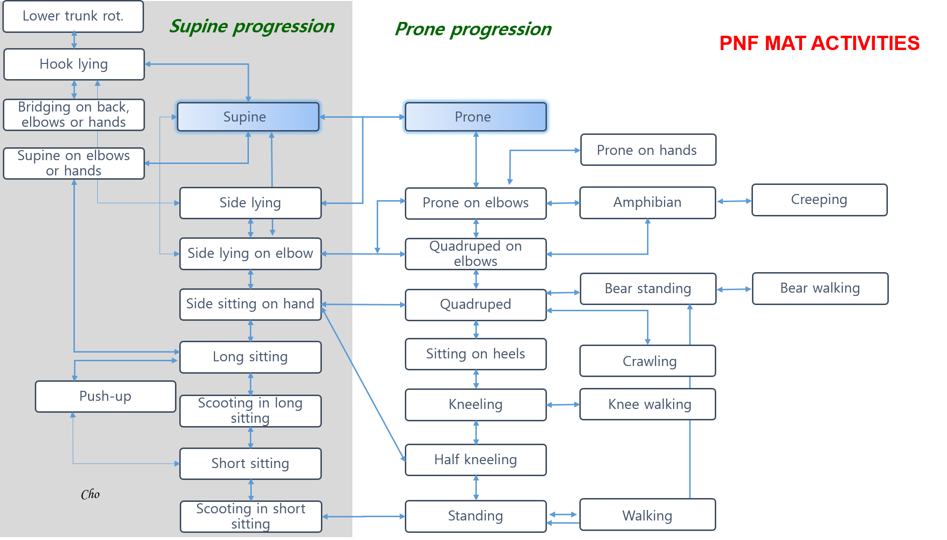

This table (Cho Gyu-haeng 2015) gives an overview of the most used positions and transitions in mat treatment, and should be seen as a list of samples only. Working with the patients there will be many other positions and actions to help them achieve their functional goals. Generally the therapist can select out of the prone or supine progression.

The following pages provide workshop papers which may help giving structure and focus on:
- Clinical reasoning (C.R.) and therapeutic indications on body structure level
- Therapeutic goals on activity level
- Patterns and tools for optimal irradiation of the activity
Shown as example: Rolling supine to the side
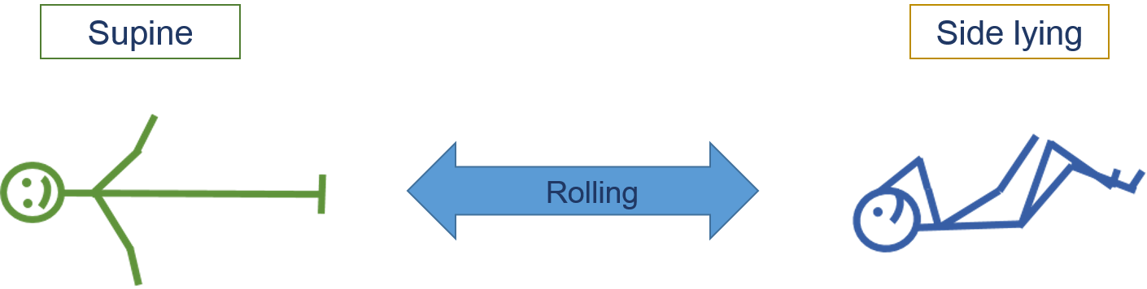

- C.R. and therapeutic indications on body structure level and on activity level:
- Strengthening
- Mobilizing the trunk, scapula, shoulder or hip
- Regulate the muscle tone
- Increasing the patient’s ability to roll
- Increasing the patient’s ability to move in bed etc.

- Patterns and tools for optimal irradiation
- Elongate or shorten the trunk muscles sufficiently.
- To reinforce the rolling, other patterns can be used together.
For activating trunk flexor muscles for rolling use:
- Neck flexion
- Scapular Ant. Depression
- Pelvic Ant. Elevation
- U/E Extension-adduction-internal rotation
- L/E Flexion-adduction-external rotation with knee flexion
- Mass flexion
- Lower trunk flexion
For facilitating the extensor trunk muscles for rolling back, use
- Neck extension
- Scapular Post. Elevation
- Pelvis Post Depression
- U/E Flexion-abduction-external rotation
- L/E Extension-abduction-internal rotation + knee extension
- Mass extension

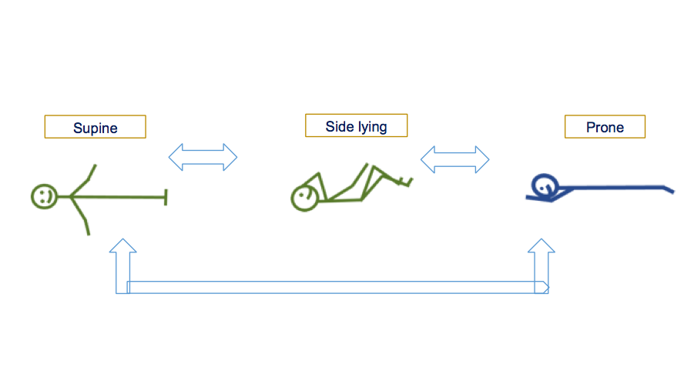

- C.R. and therapeutic indications on body structure level and on activity level:

- Patterns and tools for optimal irradiation

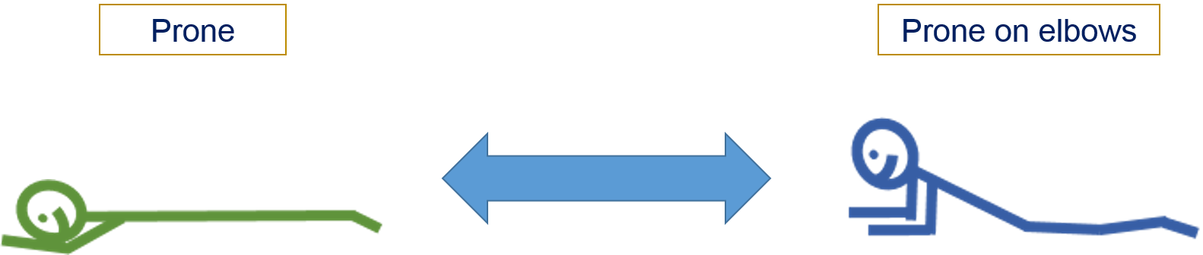

- C.R. and therapeutic indications on body structure level and on activity level:

- Patterns and tools for optimal irradiation

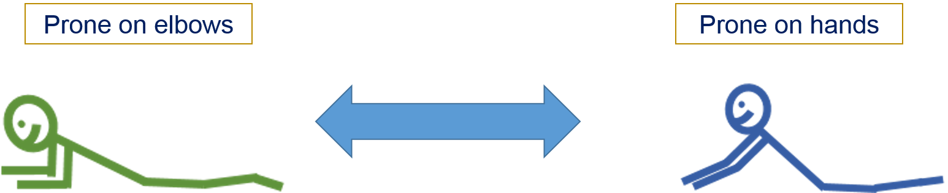

- C.R. and therapeutic indications on body structure level and on activity level:

- Patterns and tools for optimal irradiation

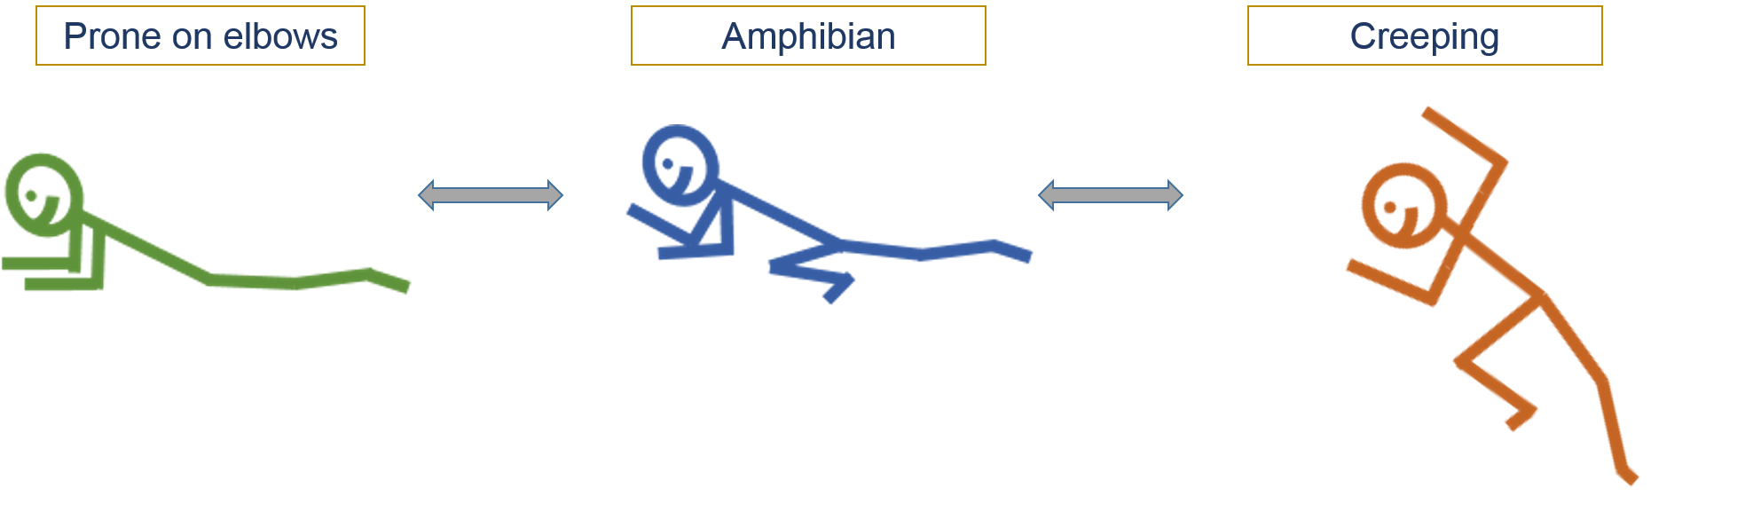

- C.R. and therapeutic indications on body structure level and on activity level:

- Patterns and tools for optimal irradiation

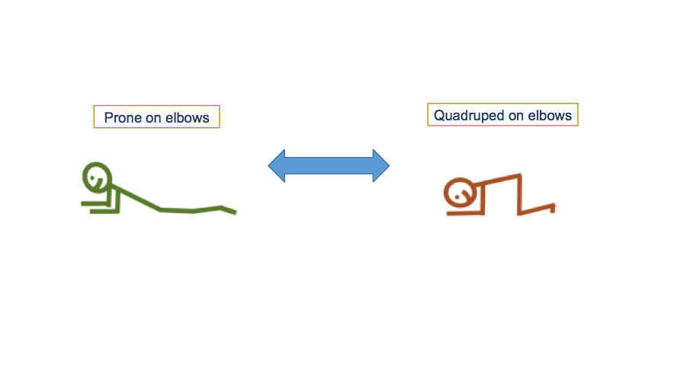

- C.R. and therapeutic indications on body structure level and on activity level:

- Patterns and tools for optimal irradiation

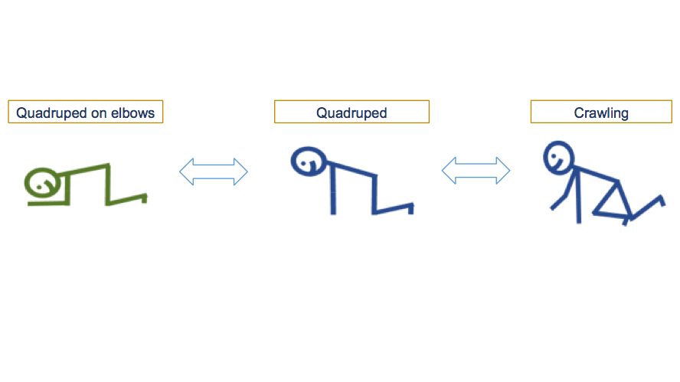
- C.R. and therapeutic indications on body structure level and on activity level:

- Patterns and tools for optimal irradiation

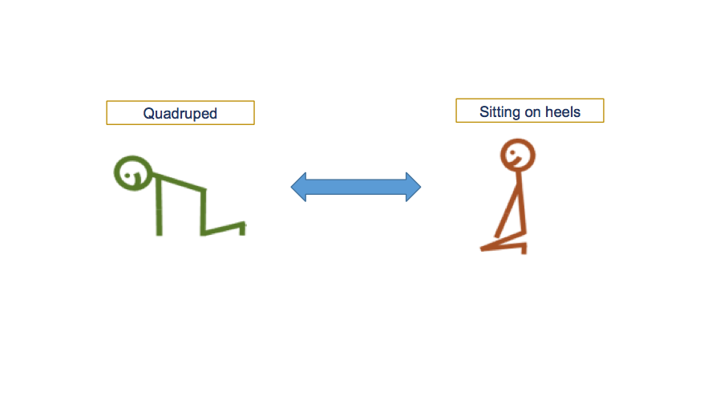

- C.R. and therapeutic indications on body structure level and on activity level:

- Patterns and tools for optimal irradiation

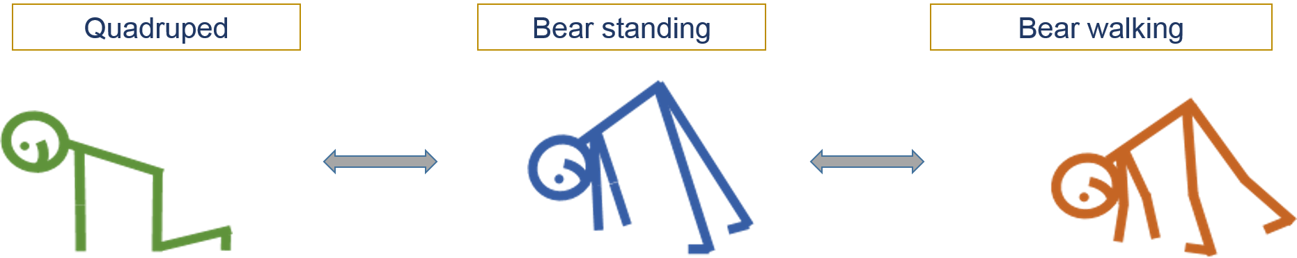

- C.R. and therapeutic indications on body structure level and on activity level:

- Patterns and tools for optimal irradiation

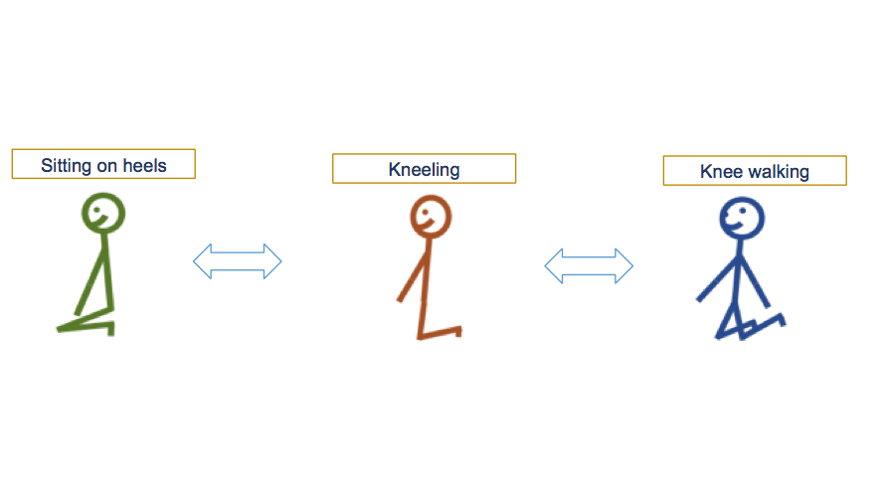

- C.R. and therapeutic indications on body structure level and on activity level:

- Patterns and tools for optimal irradiation

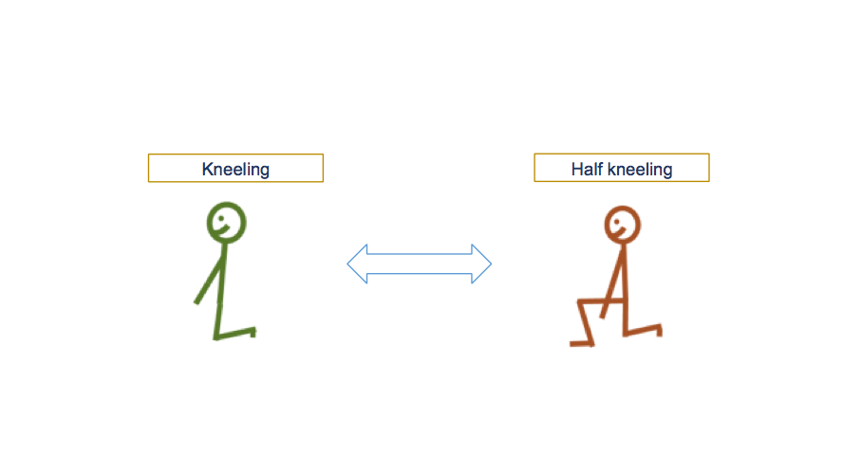

- C.R. and therapeutic indications on body structure level and on activity level:

- Patterns and tools for optimal irradiation

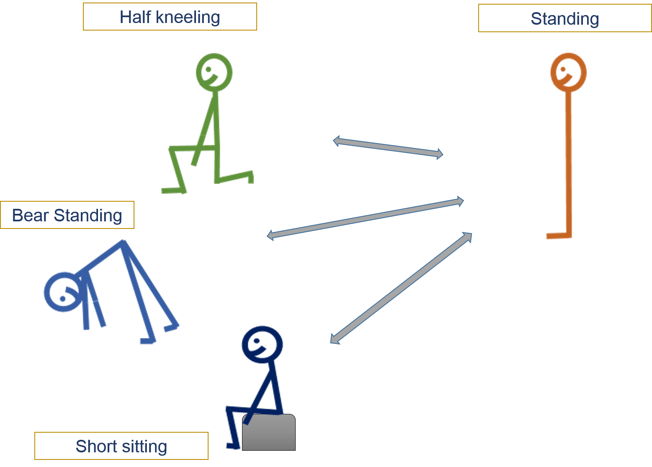

- C.R. and therapeutic indications on body structure level and on activity level:

- Patterns and tools for optimal irradiation

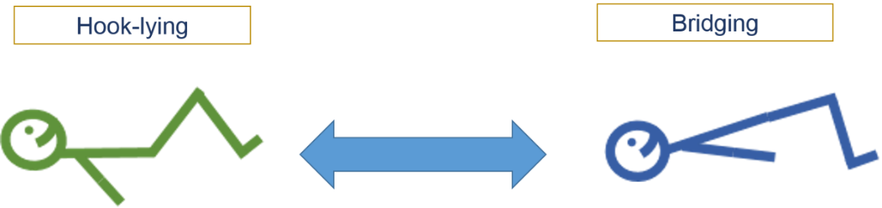
Also on hands and elbows

- C.R. and therapeutic indications on body structure level and on activity level:

- Patterns and tools for optimal irradiation

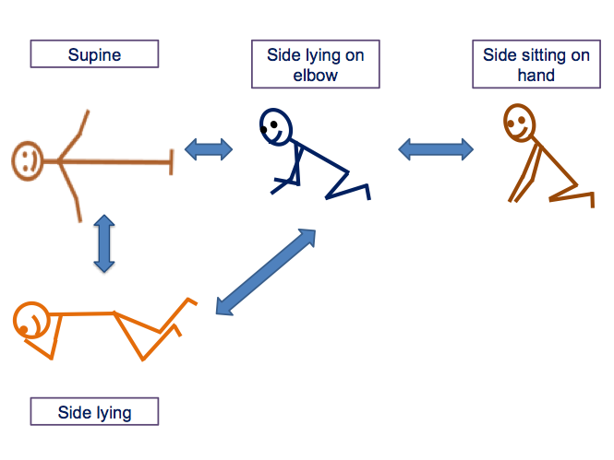

- C.R. and therapeutic indications on body structure level and on activity level:

- Patterns and tools for optimal irradiation

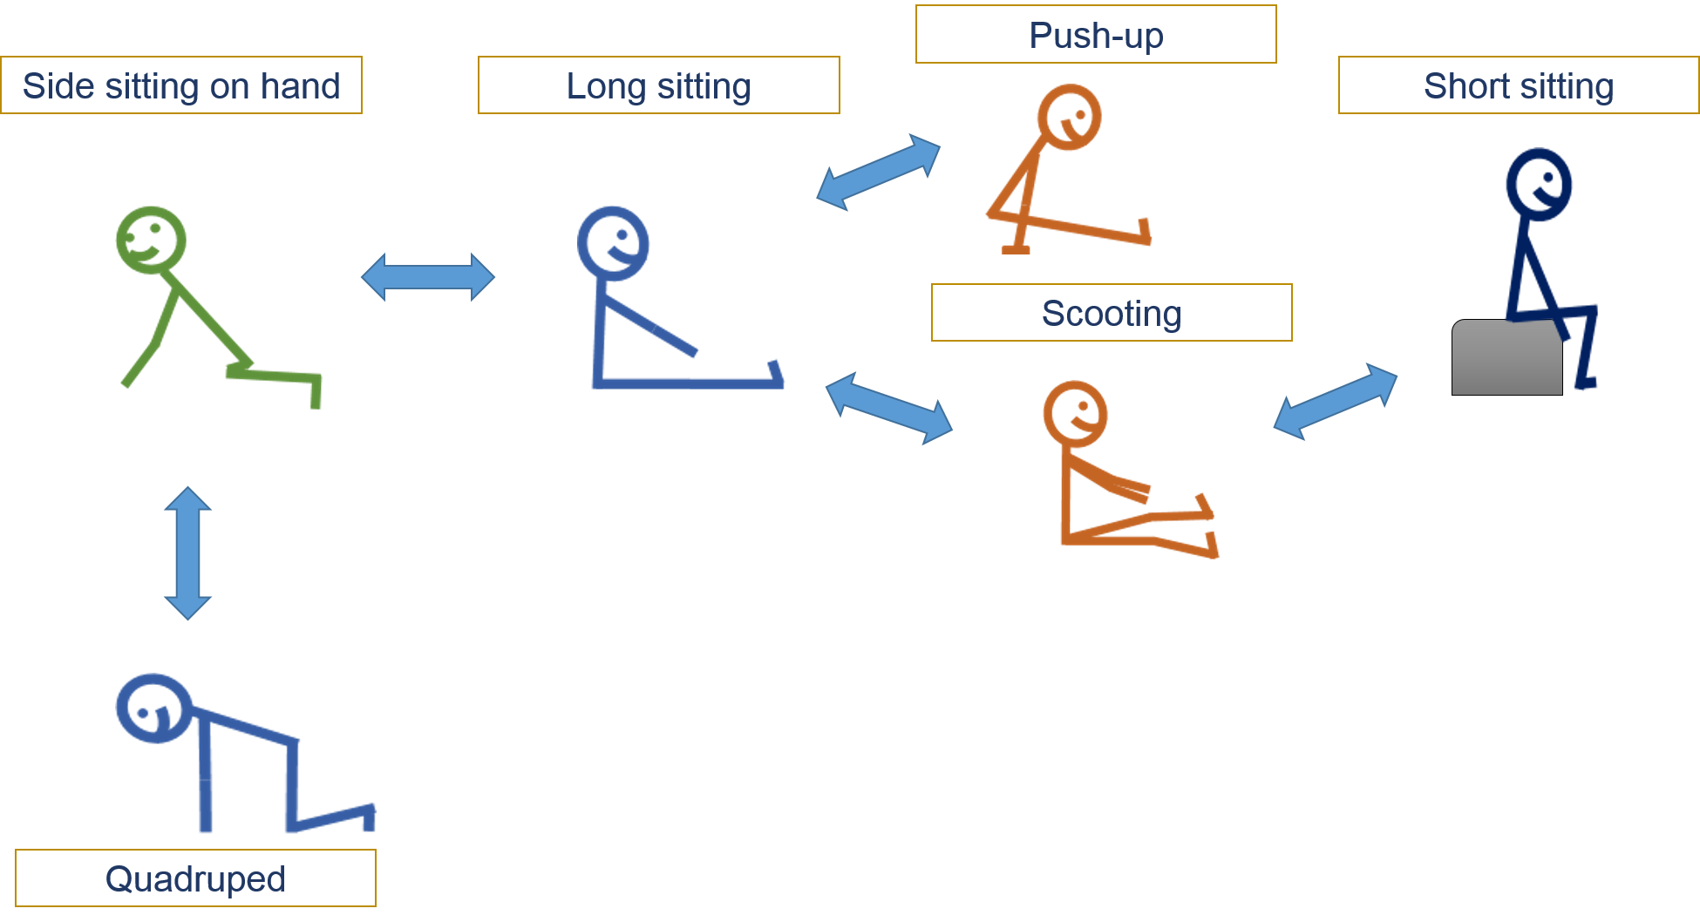

- C.R. and therapeutic indications on body structure level and on activity level:

- Patterns and tools for optimal irradiation

References

1. Adler, S., Beckers, D., & Buck, M. 2014. PNF in practice: an illustrated guide: Springer Verlag.
2. Barros Ribeiro Cilento M: Evaluation of the efficacy of train protocols of the sit to stand movement. Fisioterapi Brasil 2006 (6)
3. Beckers D., PNF-course script 2015, Belgium
4. Cho Gyu-haeng , PNF-course script 2015, Korea
5. Hedin-Andén, S. 2002. PNF-Grundverfahren und funktionelles Training., Gustav Fischer Verlag.
6. Hoogenboom BJ, Voight ML. Rolling Revisited: Using Rolling to Assess and
Treat Neuromuscular Control and Coordination of the Core and Extremities of
Athletes. Int J Sports Phys Ther. 2015 (6):787-802
7. Horst Renata, Thieme, Therapiekonzepte in der Physiotherapie PNF 2008
8. Horst Renata, Thieme, Motorisches Strategietraining und PNF 2005
9. Klein DA, Stone WJ, ea. PNF training and physical function in assisted living
older adults. Journal of aging and physical activity 2002 (10) 476-488.
10. Richter RR, VanSant AF, Newton RA: Description of Adult Rolling
Movements and Hypothesis of Developmental Sequences Physical Therapy 1989; 69:63-71
11. Santos de Britto VL, Correa R, Vincent MB: Proprioceptive neuromuscular
facilitation in HTLV – I – associated myelopathy/tropical spastic paraparesis. Rev Soc Bras Med Trop. 2014; 47(1): 24-29
12. Shin Seung-sub, PNF course script 2015, Korea
13. Stockmeyer, S. A. 1967. An interpretation of the approach of Rood to the treatment of neuromuscular dysfunction, Am. Journal of Physical Medicine & Rehabilitation , 46(1): 900-956.
14. Sullivan, P. E., & Markos, P. D. 1995. Clinical decision making in therapeutic exercise : Appleton & Lange
15. Van Sant AF (1991) Life-span motor development. In: Contemporary management of motor control problems, Proceedings of the II Step Conference. Foundation for Physical Therapy, Alexandria, VA.

