Clinical Reasoning – a bio-psycho-social model
Why....... should we care about Clinical Reasoning?
Care, because clinical reasoning gives words to what goes on in our minds.
We need to be able to explain the reasons behind our treatment choices to each other, other professionals and most importantly, our clients.
Clinical reasoning is a great way to start framing our thought processes in words and explaining the rationale behind our decisions ⁽⁵⁾.

Definitions
Clinical reasoning has been defined as “an inferential process used by practitioners to collect and evaluate data and to make judgments about the diagnosis and management of patient problems” ^{(1((p101))}.
Clinical reasoning includes the application of cognitive and psychomotor skills based on theory and evidence, as well as the reflective thought process, to direct individual changes and modifications called for in specific patient situations ⁽²⁾.
Clinical reasoning describes the thinking process and the decisions taking by the therapist during the assessment and treatment of a patient ⁽³⁾.

CR does not only addresses the diagnosis, but is also related to different patient levels such as
- disorders at activity and participation levels
- the level of patients perspective
- his/her illness experience
- levels of impairment and limitation at body structure and -function
- hypothesis regarding origin of symptoms
- patho-biological mechanisms
- influencing factors
- precautions
- management of the patients situation
- level of prognosis
- evaluation of the course of disease.

These levels of CR are considered within different CR methods:
Diagnostic Reasoning
Collecting bio-medical data (age, pulse, blood type, breathing frequence, functional problem….)
Pragmatic reasoning
Searching for best possible therapy methods, costs, location, time frame..
Interactive Reasoning
perception of patient`s emotions, needs, moral values and problems to create an appropriate relationship to the patient
Ethic Reasoning
Is the planned intervention ethically acceptable? Medical legal requirements are considered.
Narrative Reasoning
Considering narratives given by the patient. Listening to meaningful life events, current circumstances and motivation to get a feeling for the patient`s situation.
Conditional Reasoning
Prognostic intervention, suggestion for self-management, ADL- behavior ⁽⁶⁾.

CR and the conscious reflection about unconscious thinking processes may help us to recognize and discuss in a systematic and efficient way the causes, mechanisms, contributing factors, interpretation of information, holistic view at the patient and coming finally towards jointly decisions.
The two most common ways of CR are the
- Hypothetic-deductive Reasoning and the
- Pattern Recognition Method.
Hypothetic-deductive reasoning: by gathering information about origin of symptoms hypotheses are derivate. These hypotheses become either verified or falsified by further observation, questioning and tests. Mainly used by novice. Advantage: more precise, disadvantage: more time consuming
Pattern recognition method: mainly used by experts. Here the PT recognizes a typical pattern and its attributes, using just little analysis due to his/her experience (often called `disease script`). Advantage: less time consuming, disadvantage: danger of mistakes (overseen factors).
Both ways of CR need a huge amount of knowledge regarding the different diseases.

As the pattern recognition method contains the danger of overseen mistakes, therefor it is recommended to combine both methods, generating quickly hypothesis by experience which are then verified by the hypothetic- deductive procedure and its testing.⁽⁴⁾

The ability to reflect on one`s own action and thinking leads to the development of our professional expertise.
Clinical reasoning, a cycling non - linear character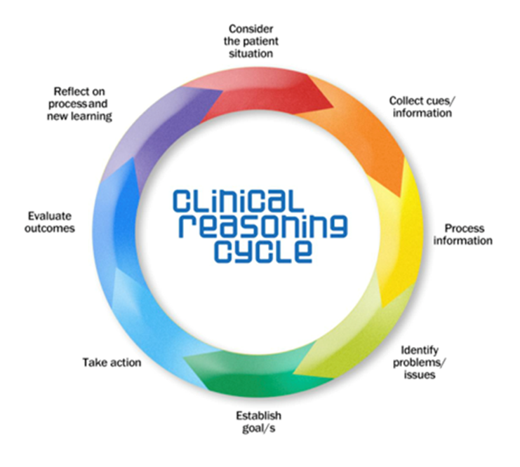

CR can be supported by e.g. a graphic organization such as a “mind-map” which we mostly organize mentally:

Example:
Activity problem: MS, unsave gait and fear of falling. Test: TUG, FES-I (questionnaire).
Causing body structures-function: spasticity-test?; ROM-test?; strength-test?; perception-test?; Balance-test?…..

Strength? MMT
Spasticity? Ashworth, Tardieu
Unsave gait, fear of falling. TUG, FES-I
Perception? Superficial-, deep perception test
Balance? Bohannon, BBS, FR….

In the PNF concept we are using the bio-psycho-social Model ICF as the underlying structure for documentation.
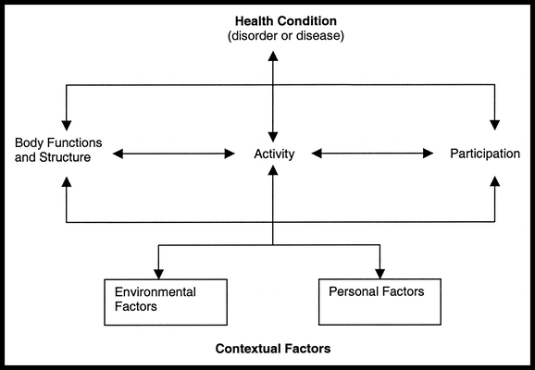

For the usage of the ICF please refer to the chapter PNF evaluation.

Test yourself:
How is CR defined? Why should you care?
Which levels of function are of interest to evaluate a patient`s situation?
Which are the 2 mostly used CR methods? Explain the difference, advantage, disadvantage.
Is the CR a linear or non- linear process? Explain!
Create a mind map for the following patient problem: Diagnosis: “Impingement-syndrome”. Activity problem: overhead arm movement is painful! What can be causing factors?
Which bio-psycho-social model is used for the PNF documentation?

Literature:
1 Lee JE, Ryan-Wenger N. The “Think Aloud” seminar for teaching clinical reasoning:
a case study of a child with pharyngitis. J Pediatr Health Care. 1997;11: 101–110.
2 Palisano RJ, Campbell SK, Harris SR. Evidence-based decision making in pediatric
physical therapy. In: Physical Therapy for Children. 3rd ed.
3 Jones MA Rivett DA: Clinical reasoning for manual therapists, Edinburgh 2004
4 Hilfiker R, Sattelmayer M.: Skript klinischer Denkprozess, Leukerbad, 1.Auflage, 2010
5 Maureen E. Neistadt: Teaching Strategies for the Development of Clinical Reasoning, American Journal of Occupational Therapy, September 1996, Vol. 50, 676-684.
6 Jensen GM, Shepard KF, Gwyer J, Hack LM. Attribute dimensions that distinguish master and novice physical therapy clinicians in orthopedic settings. Phys Ther .1992 ;72:711–722 in: Clinical Reasoning Strategies in Physical Therapy
Ian Edwards Mark Jones Judi Carr Annette Braunack-Mayer Gail M Jensen
Physical Therapy, Volume 84, Issue 4, 1 April 2004, Pages 312–330

Picture:
ICF https://www.bing.com/images/search?view=detailV2&ccid=1IM7r7hd&id=78F68E0A1B8DC895F8B3DDF2C1358B764E8EBD66&thid=OIP.1IM7r7hd
CR cycle
https://www.bing.com/images/search?view=detailV2&ccid=EEUVQRzv&id=566458C77C26201175E02A357BEE991395579DC0&thid=OIP.EEUVQRz

